Html Day One Notes

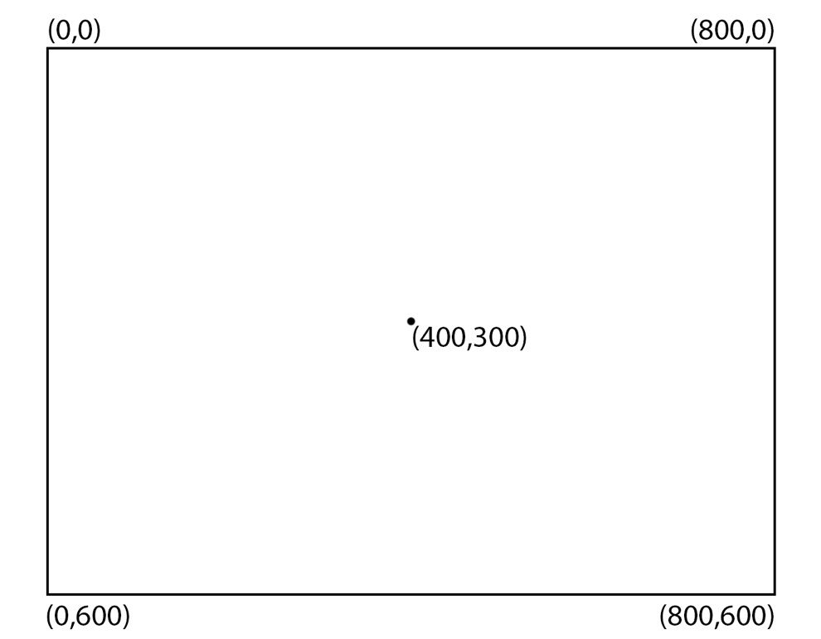

Starting Code:
<!DOCTYPE HTML>
<html>
<head>
<script>
window.onload = function() {
var canvas = document.getElementById("myCanvas");
var context = canvas.getContext("2d");

////////////////////////////////////// start below this line

////////////////////////////////////// end above this line
};
</script>
</head>
<body>
<canvas id="myCanvas" width="800" height="600"></canvas>
</body>
</html>

Line:
context.beginPath();
context.moveTo(100,150); (x coordinate, y coordinate)
context.lineTo(450,50);
context.stroke();
context.closePath();

Line Width:
context.beginPath();
context.moveTo(100,150);
context.lineTo(450,50);
context.lineWidth = 15; x = pixel width
context.stroke();
context.closePath();

Line Color:
context.beginPath();
context.moveTo(100,150);
context.lineTo(450,50);
context.lineWidth = 15;
context.strokeStyle = ‘rgb(36,122,85)’; rgb(r,g,b); each number is between 0-255
context.stroke();
context.closePath();

Line Cap:
context.beginPath();
context.moveTo(100,150);
context.lineTo(450,50);
context.lineWidth = 15;
context.lineCap = ‘round’; three options: butt/round/square
context.strokeStyle = ‘rgb(36,122,85)’;
context.stroke();
context.closePath();

Rectangle:
context.beginPath();
context.rect(150,50,200,100); (x coordinate, y coordinate, width, height)
context.stroke();
context.closePath();

Fill Style:
context.beginPath();
context.rect(150,50,200,100);
context.fillStyle = ‘red’; or the rgb scale: see line color
context.fill();
context.stroke();
context.closePath();

Triangle:
context.beginPath();
context.moveTo(400,100);
context.lineTo(700,500);
context.lineTo(100,500);
context.lineTo(400,100);
context.stroke();

Line Join:
context.beginPath();
context.moveTo(400,100);
context.lineTo(700,500);
context.lineTo(100,500);
context.lineJoin = ‘round’; three options: miter/round/bevel
context.lineCap = ‘round’;
context.lineWidth = 20;
context.stroke();

Making Notes:
///notes three forward slashes indicate a line of notes

